**A Project Report on**

**“Human Hair Mix Composite Material”**

**By**

**Mr. Rohit Kshirsagar Mr. Vaibhav Deshmukh**

(Roll No-BB38) (Roll No – BA48)

**Mr. Amar Dhumal Mr. Vaishnav Talekar**

(Roll No-BA54) (Roll No – BD31)

**Guided by**

**Prof. N. S. Biradar**



**Department of Mechanical Engineering**

**JSPM’s Imperial College of Engineering & Research, Wagholi, Pune.**

**[2022-2023]**

**JSPM’s Imperial College of Engineering & Research, Wagholi, Pune.**

**(2022-2023)**



**C E R T I F I C A T E**

This is to certify that **Mr. Rohit Kshirsagar, Mr. Vaishnav Talekar, Mr. Amar Dhumal, Mr. Vaibhav Deshmukh** has successfully completed the Project Stage-1 entitled **“Human Hair Mix Composite Material”** under my supervision, in the partial fulfillment of Bachelor of Engineering - Mechanical Engineering of University of Pune.

Date:

Place: Pune

**Prof. N. S. Biradar**

Project Guide I

**Prof. N. S. Biradar Dr. R. S. Deshpande**

Head of the Department Principal

# Acknowledgment

First and foremost, I thank the almighty God for guiding me throughout my studies till the accomplishment of this project.

I am grateful to my supervisor, **Prof. N. S. Biradar** for the useful guidance and suggestions throughout the project, it has been a great pleasure for me to get an opportunity to work under him.

We also acknowledge with thanks to, **Prof. N. S. Biradar** Head of the Department Mechanical Engineering for the support and providing facilities which helped us in the successful completion of this project.

We also thank our Principal **Dr. R. S. Deshpande** for his continued support and encouragement and motivating us.

A project of this nature could never have been attempted without reference to and inspiration from the works of others whose details are mentioned in reference section. I also acknowledge all of them.

Lastly, my thanks goes to all of my lecturers, classmates and friends in the department of Mechanical Engineering at the JSPM’s Imperial College of Engineering & Research who extended all sorts of help to the accomplishment of this undertaking.

**Mr. Rohit Kshirsagar**

**Mr. Vaishnav Talekar**

**Mr. Vaibhav Deshmukh**

**Mr. Amar Dhumal**

**Abstract**

Composite Materials are ideal for structural applications where high strength to weight ratio is required. Aircraft and Spacecraft are typical weight sensitive structures in which composite materials are cost effective.

The study of composite materials involves many topics for example Manufacturing processes , Anisotropi, Elasticity , Strength of Materials and Micromechanics.

The present work has been undertaken, with an objective to explore the potential of the Human Hair fiber polymer composites and to study the mechanical properties of composites. The present work reports the use of Human Hair fiber, as reinforcements in polymer matrix. This review focused at providing knowledge to enhance further research in this area. The influence of the source of Human Hair fiber on the mechanical properties of composites is reported. Several natural fiber composites achieve the mechanical properties of composites and they are already applied, e.g., in furniture industries etc. At present, the most important and cheap natural fibers are Jute, flax, bagasse and coir & hairs. The future of Human Hair fiber composites appears to be bright. So manufacturing of composite material by mixing Human Hair fiber in 5%,10% and 15% of total specimen volume in epoxy araldite and its strength testing on UTM is planned in this project.

**INDEX**

|  |  |
| --- | --- |
| **CHAPTER**  **NO** | **CONTENT PAGE NO** |

|  |  |  |
| --- | --- | --- |
| Sr. No. | CHAPTER | Page No. |
|  | List of Figures | 4 |
|  | Abstract | 7 |
| 1. | Introduction | 8 |
| 1.1 | Problem Statement | 10 |
| 1.2 | Objectives | 10 |
| 1.3 | Scope of Project | 11 |
| 1.4 | Classification of Composite Material | 12 |
| 1.5 | Application of Composite Material | 13 |
| 1.6 | Research Methodology | 16 |
| 1.7 | Limitations | 21 |
| 1.8 | Expected Outcomes | 21 |
| 2 | Literature Review | 22 |
| 3 | Case study | 26 |
| 4 | Experimentation | 31 |
| 4.1 | Tensile Test | 31 |
| 4.1.1 | Composite test | 32 |
| 5 | Conclusion | 33 |
|  | References | 34 |

**List of Figures**

|  |  |  |
| --- | --- | --- |
| Sr No. | Name of Figure | Page No. |
| 1.1 | Types of composites based on reinforced shapes | 13 |
| 1.2 | Structure of Boeing777 | 14 |
| 1.3 | Leaf Spring suspension made by composite materials. | 16 |
| 1.4 | Human hair | 16 |
| 1.5 | Mixing of epoxy and araldite | 17 |
| 1.6 | Mould preparation | 18 |
| 1.7 | Epoxy mixture casting | 19 |
| 1.8 | Specimen Making | 20 |
| 4.1 | Std. tensile test set up | 31 |

**List of Tables**

|  |  |  |
| --- | --- | --- |
| Sr No. | Table Name | Page No. |
| 1.1 | Project completion Schedule | 22 |
| 4.1 | Observation Table | 32 |

# INTRODUCTION

The word composite in the term composite material signifies that two or more materials are combined on a macroscopic scale to form a useful third material. The key is the macroscopic examination of a ma­terial wherein the components can be identified by the naked eye. Dif­ferent materials can be combined on a microscopic scale, such as in alloying of metals, but the resulting material is, for all practical purposes, macroscopically homogeneous, i.e., the components cannot be distin­guished by the naked eye and essentially act together.

In composite material two or more distinct materials are combined together but remain uniquely identifiable in the mixture. The most common example is, perhaps, fibre glass/carbon fiber /coir fiber /sisal fiber/ground nut shell/ hairs; one or two of this mixed with a polymeric resin. Newly investigated use in composites is human hair fiber that to investigate in this project eperimentaly. If we cut the fibres and after suitable preparation of the surface, when we look at the material, the fibres and polymer resin would be easy to distinguish. This is not the same as making an alloy by mixing two distinct materials together where the individual components become indistinguishable. There are many composite materials and while we may be aware of some, there are many others ranging from the mundane, reinforced concrete a mixture of steel rod and concrete (itself a composite of rock particles and cement), pneumatic tyres (steel wires in vulcanized rubber), many cheap plastic moldings (polyurethane resin filled with ceramic particles such as chalk and talc) to the exotic metal matrix composites used in the space program

metallic titanium alloys reinforced with SiC ceramic fibres), and in automobile, such as engine pistons (aluminium alloys filled with fibrous alumina) and brake discs (aluminium alloys loaded with wear resistant SiC particles). Regardless of the actual composite, the two [or more] constituent materials that make up the composite are always readily distinguished when the material is sectioned or broken.

Some of the properties that can be improved by forming a composite material are-

1. Strength 2. Fatigue Life

3. Stiffness 4. Temperature-Dependent Behavior

5. Corrosion Resistance. 6. Electric Insulation

7. Attractiveness 8. Acoustical Insulation

9. low weight

Naturally, not all of these properties are improved at the same time nor is there usually any requirement to do so. In fact, some of the properties are in conflict with one another, e.g., thermal insulation versus thermal conductivity. The objective is merely to create a material that has only the characteristics needed to perform the design task.

# Composite materials have a long history of usage. Their precise beginnings are unknown, but all recorded history contains references to some form of composite material. For example, straw was used by the Israelites to strengthen mud bricks.

Plywood was used by the ancient Egyptians when they realized that wood could be rearranged to achieve superior strength arid resistance to thermal expansion as well as to swelling caused by the absorption of moisture. More recently, fibre-reinforced, resin-matrix composite materials that have high strength-to-weight and stiffness-to-weight ratios have become important in weight-sensitive applications such as aircraft and space vehicles.

**1.1 PROBLEM-STATEMENT:**  
Steel and aluminium used worldwide is very hectic for transportation as heavy and having much rusting issues so need alternative material to replace it

**1.2**  **OBJECTIVES:**

1. To mould and cast the composite material.
2. To find density of new manufactured composite
3. Conduct tensile Test on the component on UTM.
4. To investigate the production process ,strength and applications of composite material.

**1.3 SCOPE OF PROJECT:**

Composites are able to meet diverse design requirements with significant weight savings as well as high strength-to-weight ratio as compared to conventional materials. Some advantages of composite materials over conventional one are mentioned below:

1. Tensile strength of composites is equivalent of steel & aluminium.
2. Improved torsional stiffness and impact properties.
3. Higher fatigue endurance limit (up to 60% of the ultimate tensile strength).
4. 30-45% lighter than aluminium structures designed to the same functional requirements.
5. Lower embedded energy compared to other structural materials like steel, aluminium etc
6. Composites are less noisy while in operation and provide lower vibration transmission than metals
7. Composites are more versatile than metals and can be tailored to meet performance needs and complex design requirements
8. Long life offers excellent fatigue, impact, environmental resistance and reduced maintenance
9. Composites enjoy reduced life cycle cost compared to metals
10. Composites exhibit excellent corrosion resistance and fire retardancy
11. Improved appearance with smooth surfaces and readily incorporable integral decorative melamine are other characteristics of composites
12. Composite parts can eliminate joints/fasteners, providing part simplification and integrated design compared to conventional metallic parts

**1.4. CLASSIFICATION OF COMPOSITE MATERIAL :**

Composites are classified by the geometry of the reinforcement — particulate, flake, and fibres

**a)** **Particulate** composites consist of particles immersed in matrices such as alloys and ceramics. They are usually isotropic since the particles are added randomly. Particulate composites have advantages such as improved strength, increased operating temperature and oxidation resistance, etc. Typical examples include use of aluminium particles in rubber, silicon carbide particles in aluminium, and gravel, sand, and cement to make concrete.

**b) Flake**composites consist of flat reinforcements of matrices. Typical flake materials are glass, mica, aluminium, and silver. Flake composites provide advantages such as high out-of-plane flexural modulus/ higher strength, and low cost. However, flakes cannot be oriented easily and only a limited number of materials are available for use.

**c) Fibre**composites consist of matrices reinforced by short (discontinuous) or long (continuous) fibres. Fibres are generally anisotropic and examples include glass and aramids. Examples of matrices are resins such as epoxy, metals such as aluminium, and ceramics such as calcium-alumino silicate. The fundamental units of continuous fibre matrix composite are uni­directional or woven fibre laminas.

# 

Fig.1.1 Types of composites based on reinforcement shape

**1.5 APPLICATIONS OF COMPOSITE MATERIALS:**

**1. Aircraft**: In commercial airlines, the use of composites has been conservative because of safety concerns. Use of composites is limited to secondary structures such as rudders and elevators made of graphite/epoxy for the Boeing 777 and landing gear doors made of Kevlar-graphite/epoxy. Composites are also used in panels and floorings of airplanes. Some examples of using composites in the primary structure are the all-composite Lear Fan 2100 plane, and the tail fin of the Airbus A310-300. In the latter case, the tail fin consists of graphite/epoxy and aramid honeycomb. Skins of aircraft engine cowls are also made of polymer matrix composites for reducing weight.

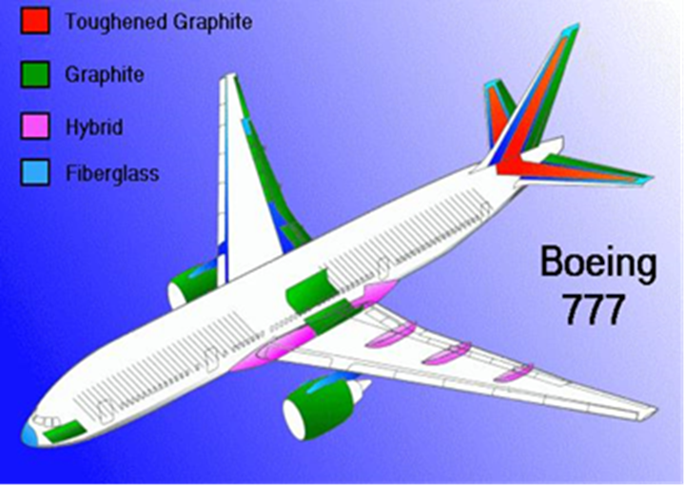

Fig1.2.Structure of Boeing777

**2. Space:** Two factors, high specific modulus and strength, and dimen­sional stability during large changes in temperature in space make composites the material of choice in space applications. Examples include the graph­ite/epoxy -honeycomb payload bay doors in the space shuttle. Weight savings over conventional metal alloys translate to higher payloads which cost as much as S1000/lb ($2208/kg). Also, for the space shuttles' remote manipulator arm, which deploys and retrieves payloads, graphite/epoxy was chosen primarily for weight savings and for small mechanical and thermal deflections.

**3. Sporting Goods:** Graphite/epoxy is replacing metals in golf club shafts mainly to decrease the weight and use the saved weight in the head. This increase in the head weight has improved driving distances by more than 25 yards (20 m).

Bicycles use hybrid construction of graphite/epoxy composites wound on either an aluminium tubing or chopped S-glass-reinforced urethane foam. The graphite/epoxy composite increases the specific modulus of the tube and decreases the mass of the frame by 25%. Composites also allow frames to consist of one piece, that improves fatigue life and avoids the stress concentration found in metallic frames at their joints. Bicycle wheels made of glass-polyamide composites offer low weight and better impact resistance than aluminium.

**4. Medical Devices:**Applications here include the use of glass-Kev-lar/epoxy lightweight face masks for epileptic patients. Artificial portable lungs are made of graphite-glass/epoxy so that a patient can be mobile. X-ray tables made of graphite/epoxy-facing sandwiches are used for their high stiffness, light weight, and transparency to radiation. The latter feature allows the patient to stay on one bed for an operation as well as X-rays, and also be subjected to a lower dosage of radiation.

**5. Marine:** The application of fibreglass in boats is well known. Hybrids of Kevlar-glass/epoxy are now replacing fibreglass for improved weight savings, vibration damping, and impact resistance. Kevlar/epoxy by itself would have poor compression properties.

**6. Automotive**: The fibreglass body of the Corvette comes to our mind when we think about automotive applications of polymer matrix composites. In addition, the Corvette® has glass/epoxy composite leaf springs with a fatigue life of more than five times that of steel. Composite leaf springs also give a smoother ride than steal leaf springs and give more rapid response to stresses caused by road shock. Moreover, composite leaf springs offer less chance of catastrophic failure and excellent corrosion resistance. By weight, about 8% of today's automobile parts — including bumpers, body panels, and doors are made of composites.

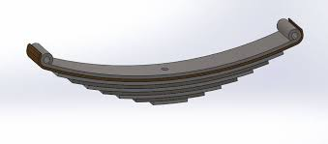

Fig.1.3 Leaf Spring Suspension

**1.6 RESEARCH METHODOLGY:**

**1**. Human hair fibers collected from saloon.

# 

2. Epoxy mixture preparation : Araldite solution of CY-230 with the hardener of HY-951 is used as epoxy (matrix) material which is available in liquid form. These two constituents are heated in oven and mixed with proper proportion. After cooling it will be converted in to solid and that solid is used as epoxy model for testing.



Fig1.5 Mixing of epoxy and araldite

3. Mould Preparation for Epoxy: Transparent acrylic sheet is used for mould preparation. Acrylic sheet of 2mm thickness is selected. The plates are cut from the sheet according to mould size. Plates are cut by some tolerance is kept for finishing. All sides of plates are finished and made perpendicular. All sheets are joined by the feviquick and box is made with one open side. After tightening of the plates the mould is well cleaned. The wax or clay material is pasted in each joint to avoid the leakage. One side of the mould is kept open to pour the mixture. Thus mould is prepared & inspected it carefully for leak

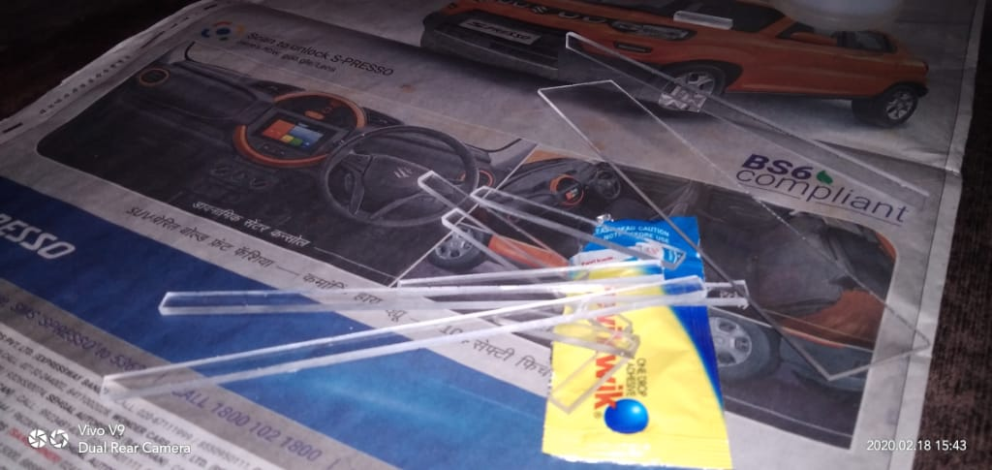

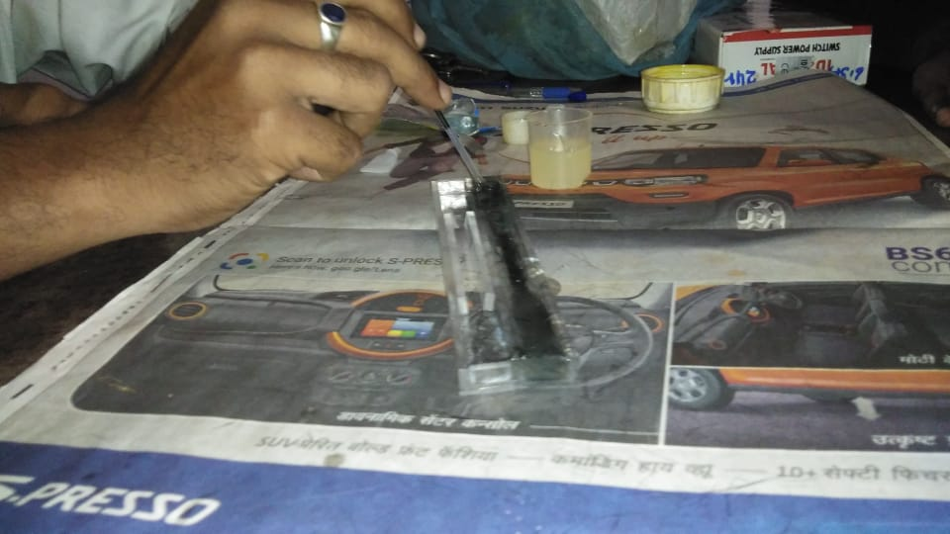5. Specimen making:

Araldite solution of CY-230 with the hardener of HY-951 is used as epoxy (matrix) material and human hair 5 % by weight are used for the preparation of composite material. Araldite solution of CY-230 with the hardener of HY-951 heated in oven and mixed with proper proportion and poured in mould. After cooling it will be converted in to solid and that solid is used as composite material model for testing.

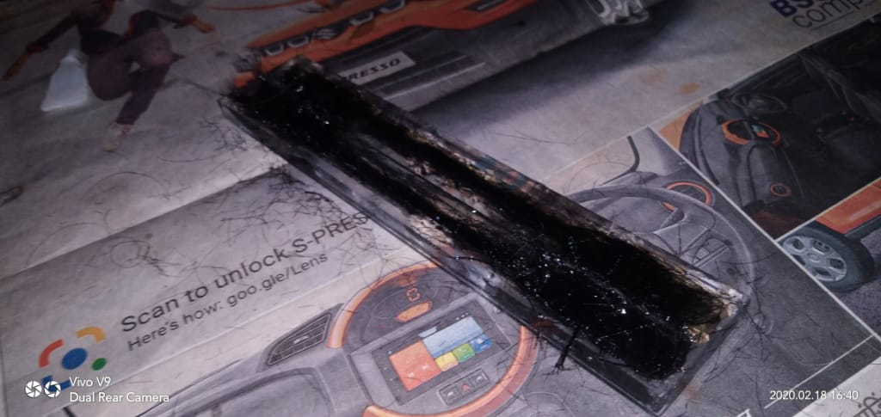

**1.8 Specimen Making**

6.Composite Material Specimen tensile testing: human hair epoxy composite is carried out from mould after two days. It is kept on plane surface for four days so that it becomes hard that hard specimen is ready for testing. Finished specimen of composite is taken and its length and cross sectional area is measured. The marking of center line along the length is done. From center line fifty mm marking on both sides is done. Then that specimen is fixed in the universal testing machine. Initial length of specimen in the Universal testing machine is measured then gradualy loaded to note deformation.

**1.7 LIMITATIONS:**

1. skilled workers not available

2. composites are brittle

3. not used at high temperature

**1.8 EXPECTED OUTCOME:**

1.learn composite making and testing

2.find alternative materials to steel and alumninum

|  |  |  |  |  |  |  |  |  |  |
| --- | --- | --- | --- | --- | --- | --- | --- | --- | --- |
| Activity in year | July | Aug | Sept | Oct | Nov | Dec | Jan | Feb | Mar |
| Topic selection |  |  |  |  |  |  |  |  |  |
| Literature survey |  |  |  |  |  |  |  |  |  |
| Problem defining and objectives, methodology |  |  |  |  |  |  |  |  |  |
| Manufacturing of composites |  |  |  |  |  |  |  |  |  |
| Experimentation, conclusion |  |  |  |  |  |  |  | |  |
| Report writing |  |  |  |  |  |  |  |  |  |

TABLE 1.1 Project completion schedule

**CHAPTER NO.2. LITERATURE REVIEW**

**___________________________________________________**

Composite materials are ideal for structural application where high strength to weight and stiffness to weight ratios are required. Aircraft and spacecraft are typical weight sensitive structures in which composite materials are cost effective. Again composite material can be designed according to desired properties for getting the required properties of composite material analysis of these properties is essential. Many researchers have devoted their research on analysis of composite material many organizations are also continuously working on composite material, some of them have discussed here.

We investigated that composite materials are now-a-days replacing the traditional materials because of its superior properties such as high tensile strength, low thermal expansion and high strength-to-weight ratio. Natural fibre composites such as groundnut shell polymer composites and coir composites have become more attractive due to their high specific strength, light weight and biodegradability. This work attempts to study particulate natural fiber based epoxy composites. It is concerned with the preparation and testing of composite materials from groundnut shell fibres and coir fibres along with binder and epoxy resins. The groundnut shells are chemically washed, cleaned and then dried in sunlight. The dried shells are then grinded to particle sizes of 1 mm, 1.5 mm, 2 mm and the epoxy resins are added in 70:30 ratio by weight to the fibres in a 12 mm thick mould and different flat square-shaped composites are obtained. Specimens of different particle sizes are cut into standard dimensions as per ASTM for different mechanical and moisture absorption tests. The results thus obtained are relatively compared between groundnut shell and coir fiber composites so as to suggest suitable applications. In general, the coir fibre composites are found to be comparatively better than groundnut fibre composites particularly considering the mechanical properties.

An advanced book on **mechanics of composite material by R. Jones** covers applications of composite materials and micromechanical and macro-mechanical behavior of lamina and laminates as well as the design of the composite structure. They have derived theoretical methods for the analysis of composite materials. An advanced **book on mechanics of composite material by Autar K. Kaw** covers applications of composite materials and micromechanical and macro-mechanical behavior of lamina and laminates as well as the design of the composite structure. They have derived theoretical methods for the analysis of composite materials and explained PRIMAL Software for micro and macro mechanical analysis of lamina. A book on **metal matrix composite by N. Chawla and K. K. Chawla** has given the micromechanical analysis for the composite material. They have used some numerical methods for micromechanical analysis of the composite material

In the investigation of effects of randomness on band gap Formation in Models of Fiber-Reinforced Composite Panels Having Quasirandom Fiber Arrangements, Large-scale deterministic simulations are performed to observe the band gap formation in composite models having quasirandom fiber arrangements. Different quasirandom fiber arrangements are computationally generated using the same control parameters.

# 

Statistical parameters are used to quantitatively describe the fiber arrangements. Subsequently, a series of arrangements is generated from each base line arrangement by scaling up the coordinates of fiber centers, while the fiber diameter remains unchanged to study the effects of fiber spacing. Simulation results are compared with the corresponding case of ideally regular fiber arrangement. The most interesting observation is that the slight randomness in the fiber arrangements enhances the band gap phenomenon by introducing a few secondary band gaps adjacent to the primary band gap.

A mechanism-based progressive failure analyses (PFA) approach is developed for fiber reinforced composite laminates. Each ply of the laminate is modeled as a nonlinear elastic degrading lamina in a state of plane stress according to Schapery theory (ST). In this theory, each lamina degrades as characterized through laboratory scale experiments . Special Features are built into a user-defined material subroutine that is implemented through the commercial finite element (FE) software ABAQUS in conjunction with classical lamination theory (CLT) that considers a laminate as a collection of perfectly bonded lamina . The success of the present PFA methodology is encouraging and points the way for extending the methodology to analyze other structural configurations.

In a study of stiffened panels subjected to shear loading a Composite Structures . Experimental and analytical results are presented for a progressive failure of stiffened composite panels with and without a notch and subjected to the in-plane shear loading well into the post-buckling regime. Good agreement between experimental data and numerical results is observed for the stitched stiffened composite panels studied .

**CHAPTER NO.3. CASE STUDY**

**____________________________________________________________**

Biological fibers have recently became eye-catching to researchers, engineers and scientists as an alternative reinforcement for FRP (fiber reinforced polymer) composites, due to their low cost, fairly good mechanical properties and high aspect strength. One of the immaculate biological fibers is the human hair. On the whole, three to four tons of human hair fibers are wasted in India annually; hence they pose an environmental challenge. In order to find commercial application the wasted human hair fibre is nowadays finding its use in the field of material science. Human hair is basically a nano-composite biological fiber with well characterized microstructures. Different techniques and technologies have been employed to study the different characteristics of the human hair to prove it a biological composite fiber. The main component of hair is keratin which is tough, insoluble and incredibly strong. An important aspect is that a single strand of hair can withstand the load of 100-150 grams. Hair is elastic and it is capable of regaining its original position on removal of the deformation load.

A Composite material may be defined as a combination of two or more materials that leads to better properties than those of the individual components used alone. In comparison with metallic alloys, each material retains its separate chemical, physical and mechanical properties. The two main constituents are a fiber and a matrix. The main merits of composite materials are their high stiffness and strength, combined with low density, when compared with bulk materials, allowing a weight reduction in the finishedmaterial. The reinforcing phase provides the strength and stiffness. In most cases, the reinforcement is harder, stronger, and stiffer than the matrix. A fiber has a length that is much greater than its diameter. The length-to-diameter ( *l* / *d* ) ratio is known as the *aspect ratio.* and can vary vastly. Continuous fibers have long aspect ratios, while discontinuous fibers have shorter aspect ratios. Continuous-fiber composites normally have regular orientation, while discontinuous fibers generally have a random orientation.

Hair threads form a major part of the external covering of most mammals. In the humans, hair represents a structure which long time ago lost their functional significance during the species evolution. The hair thread has a cylindrical structure, highly organized, formed by inert cells, most of them keratinized and distributed following a very precise design. Hair forms a very rigid structure in the molecular level, which is able to offer the thread both flexibility and mechanical resistance. Hair is considered as a dead matter and it is only alive when it is inserted in the scalp. When the thread emerges, it becomes dead matter although it appears to be growing since the fiber follows increasing its length by a speed of about 1.0 cm/month. Human hair has about 65-95% of its weight in proteins, more 32% of water, lipid pigments and other components. Chemically, about 80% of human hair is formed by a protein known as keratin (Kaplin *et al*., 1982; Wagner, Joekes,2005).Threads present significant structural differences, according to the ethnic group, and within the same group. The factors we have are: resistance, elasticity, diameter, bending, shape of the cross section and color. In spite ofdepending on threads characteristics and on the morphological components integrity, cosmetic properties are: volume, malleability, shine, combing retention of styling, and ability of flying away. Hair has a particular genetic nature. We may handle it and applying on it products to mimic differences of the touch sensorial characteristics; these are, however, transient effects (Juez, Gimier, 1983; Dias, 2004).

*B. Preparation*

Two mold plates were taken and a template of 210*210 mm size which is the size of the composite was readied with in their boundaries. The composite was made by collecting hair from various sources and making them into beds of minute thickness by hand rolling in such a way that the follicles are interlocked. Taking approximately 20gms of hair for each bed three such beds were made. After this a bunch of approximately 4inchlong hair was taken and small groups of follicles were removed each of approximately same thickness and placed separately in longitudinal fashion. About 50 such strands were formed. The epoxy resin was made with a composition of Araldite LY556 to HY951 hardener in the ratio of (10:1)and mixed well.

*Fabrication Process*

  A portion of the mixed resin was applied on the inner side of the template. Then one of the rolled bed was placed and arranged precisely within the boundaries. This was allowed to dry for about 2 minutes before the second layer of epoxy was poured on top of it and spread evenly by using an MS roller held by a handle. Then they formed strands, about25of them, were placed longitudinally, uni-directionally on top of the resin at an orientation of 0 degree with respect to the first bed. Then the epoxy resin was poured on top of the second bed and evenly spread by using the MS roller. Then the second bed was used as the third layer and same procedure was followed. Then third bed was used as fourth layer by repeating same procedure. Then the remaining strands were placed on the top as last layer with an orientation at 0 degree with reference to previous layer of strands and all the remaining epoxy was poured on top.

Another nicely waxed gloss paper cut to the dimensions of the mold plate was used to cover the top of the material. Then 4mm thick spacers were placed at the vertices of the template in or der to ensure non-tapered surface and even thickness throughout. The top mold plate was placed on this preparation for sandwiching it. Then the setup was placed in a fixture and tightened fully until the excess epoxy flowed out and a proper setting was obtained and was left undisturbed for one day. After checking the proper curing of the composite, it was removed from the fixture, separated from the mold plates, the gloss paper was torn and the composite made ready. After the composite was fabricated it was cut into standard dimensions and the weight was measured.5 similar materials were fabricated for conducting various mechanical tests.

**TESTING**

*A. Tensile Test: ASTM D638-03*

Tension testing is a fundamental materials science test in which a specimen is subjected to a controlled tension until failure. Composite specimens are tested for tensile strength as per ASTM D 3039 test standard. The tensile strength and elastic modulus are given in Table 2.The specimen was loaded in servo assisted hydraulic -Universal testing machine having gauge length of120mm.The grips were tightened evenly and firmly to prevent any slippage. The speed of testing was set at the proper rate of 1mm/min and the machine was started. As the specimen elongates, the resistance of the specimen increases, and it was detected by a load cell. The vice was fitted firmly and zero reading was observed. Then step by step loading was carried out until the specimen failed at the maximum load. A plotter plots the load vs deflection curve results on the graph sheet. The stress vs strain curve was plotted from the plotter results. The tensile strength was calculated from the test results.

*B. Flexural Test: ASTM D790*

The flexural properties of the composites were evaluated using the Universal Testing Machine, with a cross head speed of 1mm/min and span length of 50 mm. The flexural strength was measured as per the ASTM D 790.The test specimen was positioned horizontally over the two supports of the testing machine The upper grip was moved downward, i.e. the load was applied perpendicular to the specimen surface. The speed of testing was set at the proper rate and the machine was started. A plotter was connected to the testing machine. The deflection of the specimen was continued until a rupture of the specimen was observed. A plotter plots the load vs deflection curve results on the graph sheet. The stress vs strain curve was plotted from the plotter results. The flexural strength was calculated from the test results.

*C. Impact Test: ASTM D256*

Impact testing is done for determining the toughness of a material against sudden force or impact. Izod impact testing is an[ASTM](https://en.wikipedia.org/wiki/ASTM)standard method of determining the impact resistance of materials. A pivoting arm is raised to a specific height (constant[potential energy)](https://en.wikipedia.org/wiki/Potential_energy) and then released. The arm swings down hitting the sample, breaking the specimen. The energy absorbed by the sample is calculated from the height the arm swings to after hitting the sample. A notched sample is generally used to determine.

**CHAPTER 4 EXPERIMENTATION**

The tensile testing of the samples will be done in accordance with ASTM D638 standards. The samples made to dumbbell shape and then placed in the universal tensile testing machine and the tensile strength will be evaluated.

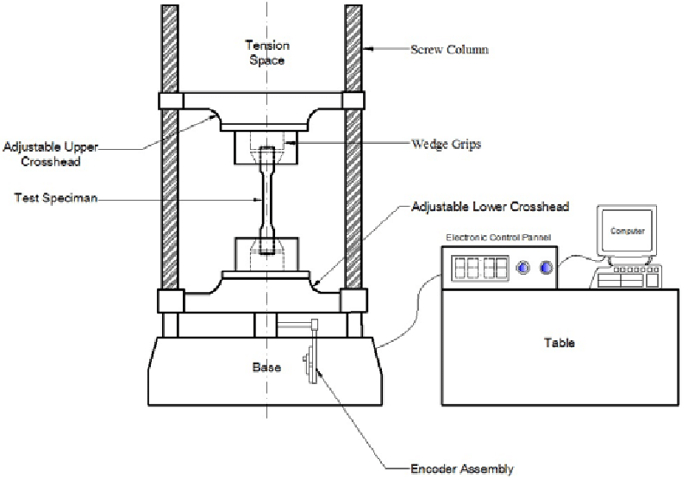

**Fig 4.1 Std tensile test set up**

**4.1.1 Composite Test:**

Hair epoxy composite from mould is removed out from mould after two days. It is kept on plane surface for four days so that it becomes hard that hard specimen is ready for testing. Finished specimen of composite is taken and its length and cross sectional area is measured. The marking of center line along the length is done. From center line fifty mm marking on both sides is done. Then that specimen is fixed in the universal testing machine. Initial length of specimen in the Universal testing machine is measured then gradualy loaded to note deformation

**Table 4.1: Result of Tensile Tests**

|  |  |  |  |  |  |
| --- | --- | --- | --- | --- | --- |
| CATEGORY | WIDTH MM | THICKNESS MM | CROSS SECTION AREA MM2 | LOAD-N | TENSILE STRENGTH  MPa |
| 5% HAIR MIX |  |  |  |  |  |
| !0% |  |  |  |  |  |
| 15% |  |  |  |  |  |

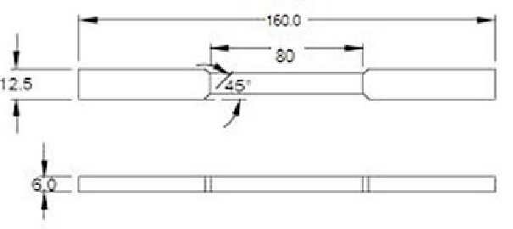

Fig. 4.6. Standard specimens for Tensile test

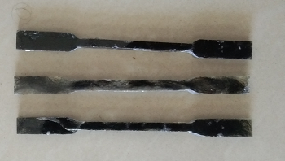

Fig .4.7 -3 specimens

**CHAPTER NO. 5 CONCLUSION**

**______________________________________________________**

Hair b[ased polymer composites. In the present work, hair](https://www.ijert.org/) [composites are developed and their mechanical](https://www.ijert.org/) [properties are evaluated. Also a step forwarded to](https://www.ijert.org/) [use the waste material technically and enhance](https://www.ijert.org/) [the properties of several existing material which can](https://www.ijert.org/) [be more useful and can have advanced properties](https://www.ijert.org/) [than the existing form.](https://www.ijert.org/)

Composite material can be designed and manufactured according to required properties. The key material properties for usual engineering mechanics applications are strength and stiffness. The usual design criterion for composite material is based on trying to align the fibres with most critically loaded directions of mechanical component. Again critical percentage of volume fraction of matrix material and fibre is also considered while designing the composite material. It is very important to find out elastic constants and other mechanical properties of an orthotropic (hair) composite lamina experimentally as many times theoretical and finite element approach for these may not give true results.

**REFERENCES**

1. Liang M. Jones “Mechanics of Composite Materials” Taylor and Francis ltd. second edition 1999
2. Banu ki,“Mechanics of Composite Materials”. CRC press New York 1997.
3. Damodar ,“Metal Matrix Composite” Springer publication, New York, first edition 2006.
4. Tita, “Investigation of Fracture in Transparent Glass Fibre Reinforced Polymer Composites Using Photo elasticity” ASME Journal of Engineering Materials and Technology January 2004, Vol. 126
5. Hubertus,”Material Characterization of Glass, Glass, and Hybrid-Fibre SCRIMP Panels” Contractor Report for Sandia National Laboratories
6. Josef, “Durability-Based Design Criteria for a Chopped-Glass-Fibre Automotive Structural Composite” ORNL/TM-1999/182
7. T. Y. Kam, C. H. Lin. “Identification of Material Constants of Composite Laminates Using Measured Strains” ASME Journal of Engineering Materials and Technology OCTOBER 2000, Vol. 122 ’ 425.
8. Dr. Roberto Lopez-Anido, Mr. Fadi W. El-Chiti,Dr. Lech Muszyñski, and Dr. Habib J. Dagher “Composite Material Testing Using a 3-D Digital Image Correlation System” COMPOSITES 2004 Convention and Trade Show American Composites Manufacturers Association October 6-8, 2004